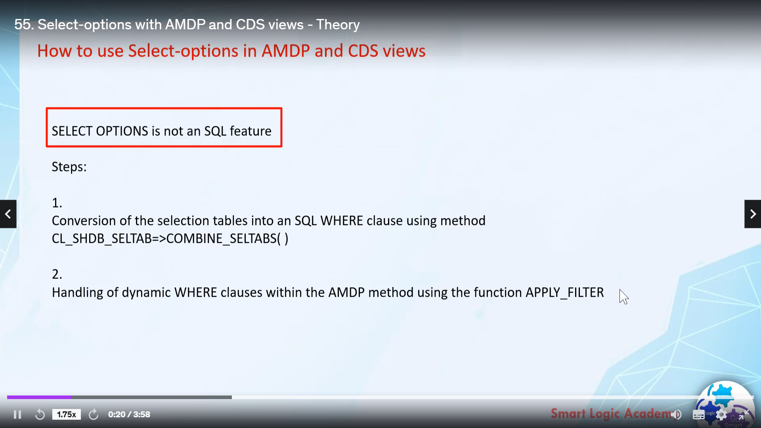

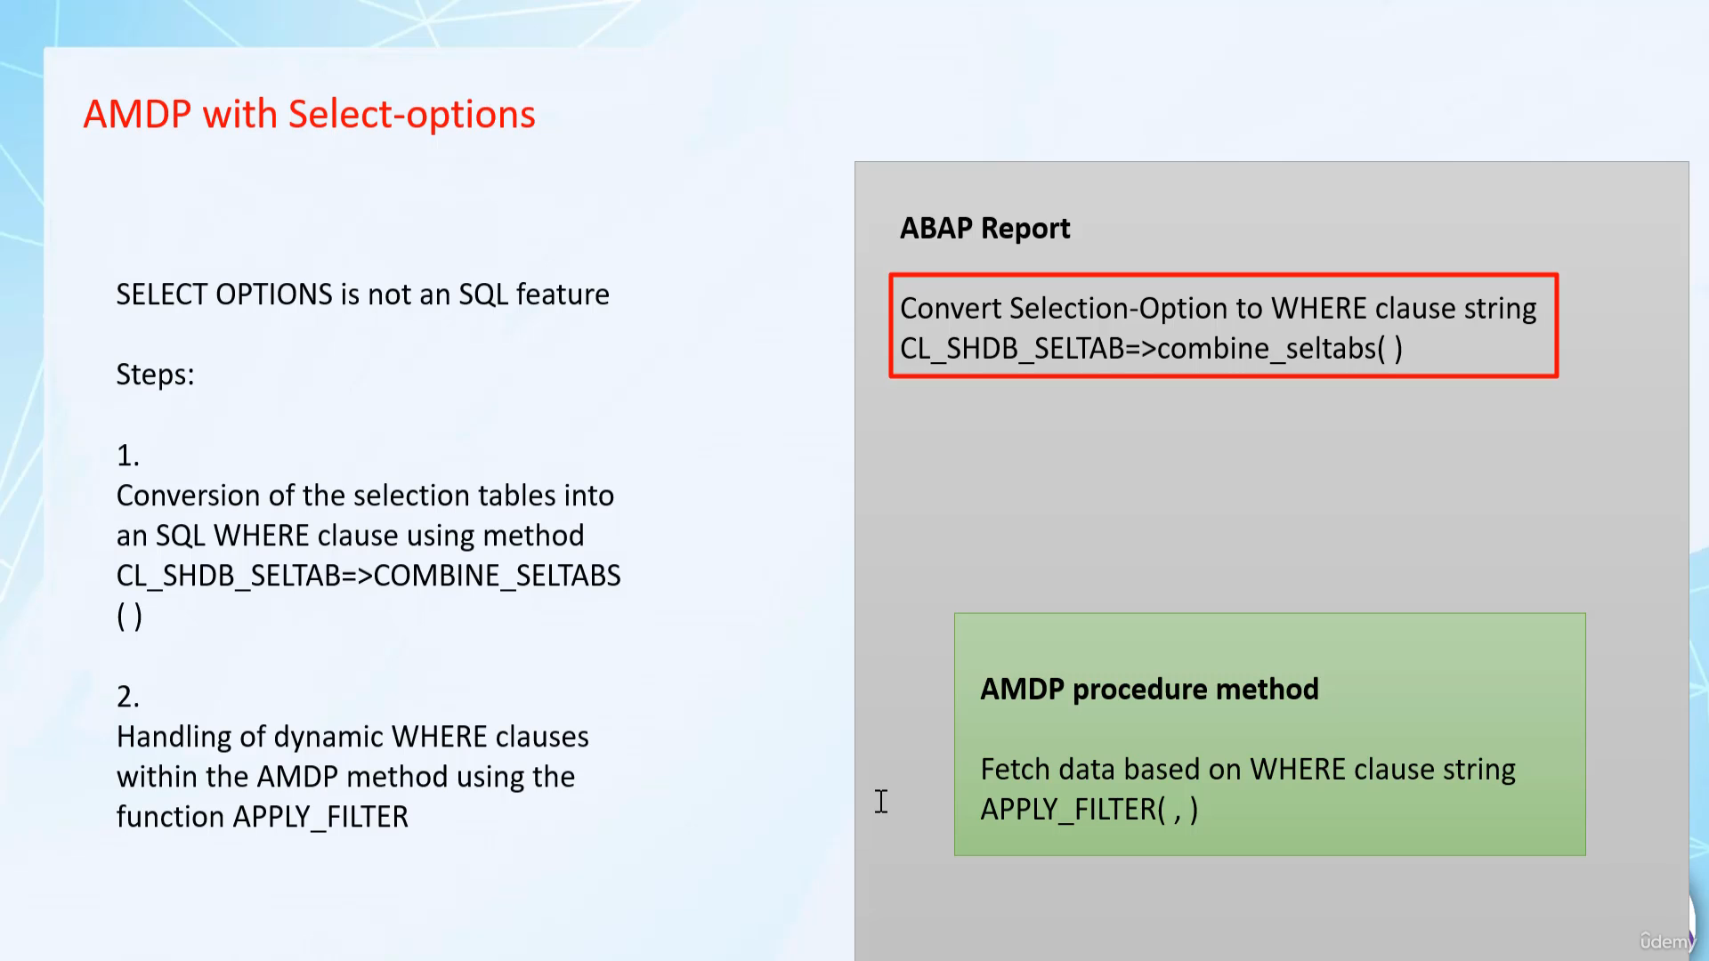

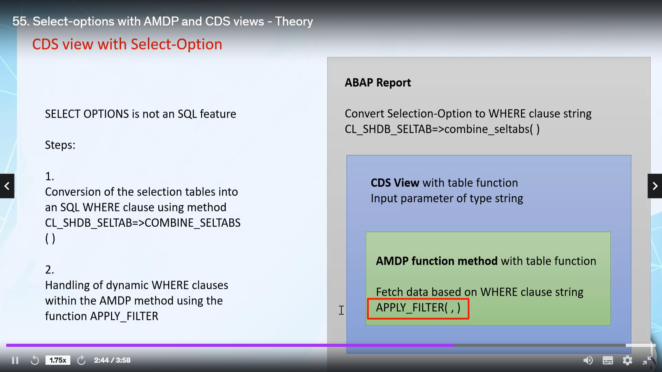

Hi, welcome back in this video tutorial, we will see how to push down select option feature off abruptly

to aim deep and serious.

It's very important for you to know that select option is not an essential feature, extend ABAP or

open a scroll feature, which it still doesn't understand.

So thinking to put this select option variable directly to database layer is not possible.

The only filtering technique a skill can understand is using their close.

And the select options, we how many choices of passing inputs like equestrian articles to compare.

So if we can convert these options into very close understood by a school, we can execute it dynamically

in the database.

For that, you have to follow two steps in step one.

You are to convert selection option table into an obscure, very close street.

And it's still too have to use that word clustering to fetch the desired data.

Step one, we will be performing on other people and step two.

We will be performing on IMDb meter.

To perform step one, we can use method combined slabs of glass.

I said, do certain.

To perform step two, we can use function, apply filter, apply filter is a simple one hundred and

two will feature.

Now, let's see, how do you select options aimed?

We will create one.

I'm happy to put in that report.

We will convert select option two billion to vertical string using method combines the depth of class,

I said do debt.

Then we will call the procedure matter directly in a lab report, and we will pass that word clustering.

In IMDb procedure, Mr We will find data based on their clustering that we have parsed using a ACP Hanna

Point shouldn't apply to that.

OK, now let's see.

How do you select options with serious?

Again, the same thing in our report, we will convert selection auction table into work clustering.

But now here, as we know to data based on a work clustering, we have to use a black filter.

But since a black filter is a need to expand a feature, we can't directly use it inside silliest foods.

So what we need to do is we will create one studio two with table function, implementing one in the

prevention method and inside that aimed at prevention matter.

We will use funds to apply filter.

So please make a note here whenever you want to use select option with serious view.

You have to use to disprove it.

They will function and to push down the select option functionality to database.

We will be using MDT function method.

And in case of IMDb, we will use IMDb procedure method.

At this moment, if you have any doubts or if you don't understood any point.

Don't worry, this will be just an overview.

All your doubts and questions will get cleared out in a practical session.